**Name: Lingaiah Thammisetti**

**Home Assignment**

**Now that you have uploaded and installed the Hadoop VM and have experienced creating a file you should go a step further and make some changes to the existing file. You should use the Hue environment and copy the "Hello world in HDFS" line ten times. Save the newly edited file under the same name and place.**

**Take a look how large is the file and report back the number of KB this newly updated file size.**

**Answers:**

Command:touch testfile.txt

After that , you write a line in this test file using the command.

Command:echo "Hello world in HDFS" >> testfile.txt

Now we see that the file size has increased to 20 Bytes as shown in the figure below:

To display the content of the test file on the terminal, you use the below command as shown in the screen shot. Command:cat testfile.txt

You can now, load the file from the terminal to HDFS with the following command,

Command:hdfsdfs -put testfile.txt

After you upload the file in HDFS database, you can see it in the directory. It shows the file size in the HDFS directory as 20 bytes as well. See the screen shot below.

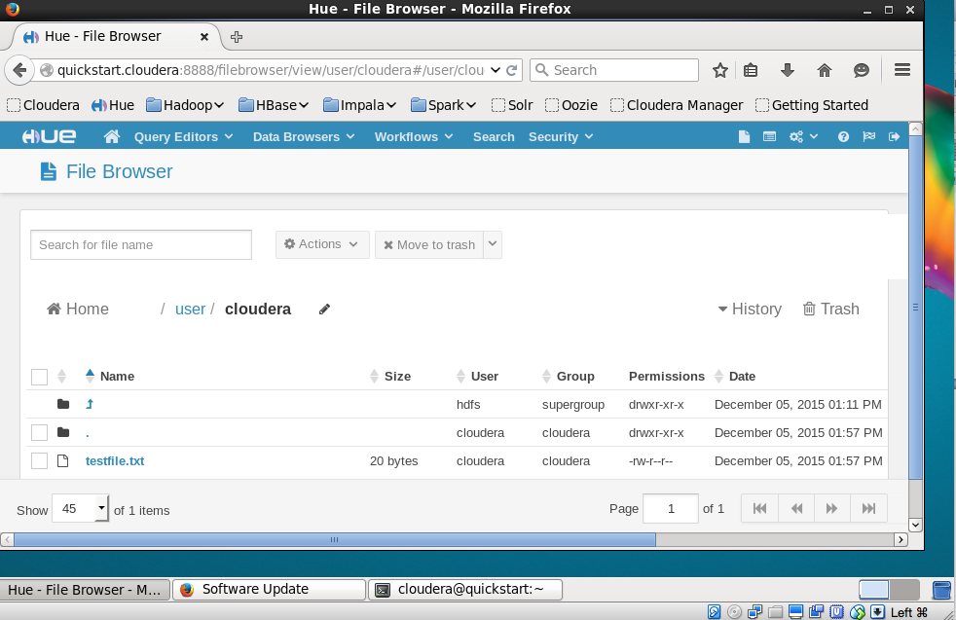

Now you go back to terminal and edit the testfile1 .txt by adding 9 more lines using the same command 9 more times.

You can now, load the file from the terminal to HDFS with the following command,

Command:hdfsdfs -put testfile1.txt

The testfile.txt still shows in the HDFS directory structure as 20 bytes.

You can save the testfile.txt as testfile1.txt in terminal and then upload it on HFDS directory.

Upload testfile1.txt in the HDFS directory.

Now if you see in the HDFS directory the new file “testfile1.txt” and older file “testfile.txt” both show up.

testfile.txt is 20 Bytes

testfile1.txt is 200 Bytes.

Screen Shot:

